**SOFTWARE REQUIREMENT SPECIFICATION**

**DOCUMENT**

**CALCULATOR SYSTEM**

**Version:** Version 2.0

**ABSTRACT**

This document is intended to be the SRS for developing **CALCULATOR SYSTEM**

|  |  |  |  |
| --- | --- | --- | --- |
| **Project Title** | **CALCULATOR SYSTEM** | | |
| **Lead Institution** | **THE INTERNATIONAL SCHOOL - DUY TAN UNIVERSITY** | | |
| **Project Mentor** | **Mr. Nguyen Dang Quang Huy** | | |
| **Team Name** | **Team 2** | | |
| **Team Members** | **Bui Thanh Nghia** | | |
| **Tran Quang Hieu** | | |
| **Huynh Duc Huy** | | |
| **Vo Hung Cuong** | | |
| **Nguyen Trung Kien** | | |
| **Start Date** | Jan 20, 2024 | **End Date** | March 1,2024 |

**ROPRIETARY INFORMATION**: The information contained in this document is the property of **TEAM 2**. Except as specifically authorized in writing by **TEAM 2**, the holder of this document shall keep all information contained herein confidential and shall protect same in whole or in part from disclosure and dissemination to all third parties

**Table of Contents**

Revision History 4

1. Introduction 6

1.1. Purpose 6

1.2. Intended Audience and Reading Suggestions 6

1.3. References 6

2. Project Overview 6

2.1. Project Description 6

2.2. Business Need 7

2.3. Project Analyst 7

2.3.1. Business Function Diagram 7

2.3.2. System Context Diagram 8

2.4. Software Requirement Specification 8

2.4.1. High level Functional Requirement (FR) 8

2.4.2. Stakeholders 12

2.4.3. Use case 12

2.4.4. List of use case 13

UC 01: Addition 13

UC 02: Subtraction 14

UC 03: Multiplication 15

UC 04: Division 17

UC 05: Division with raminder 18

UC 06: Squaring 19

UC 07: Squaring Root 21

UC 08: Backspace 23

UC 09: Delete 24

UC 10: Clear All 25

2.4.6 . Activity Diagrams 26

Addition 26

Subtraction 26

Multiplication 27

Division 28

Division with remainder 28

Square 29

Square Root 29

Backspace 29

Delete 30

Clear All 30

Appendix A: Glossary 31

# Revision History

|  |  |  |  |  |
| --- | --- | --- | --- | --- |
| **Date** | **Change Iterm** | **Description** | **by** | **Version** |
| **20/1/2024** | Get requests from customers | After preparing the questions about the request and received the request from the customer | Tran Quang Hieu | Version 1.0 |
| **20/1/2024** | Start team meeting | Meet and refer to a number of training points, read through the training points and focus on project implementation, the team can fully understand the system requirements to create | Tran Quang Hieu, Vo Hung Cuong, Huynh Duc Huy, Bui Thanh Nghia, Nguyen Trung Kien | Version 1.0 |
| **21/1/2024** | Job analysis | Through specific requirements, analysis, clearly speaking, the leader needs to prepare in advance for the members. | Tran Quang Hieu, Huynh Duc Huy | Version 1.0 |
| **21/1/2024** | Share the work | Get BFD, contextual diagram, DFD level 1, DFD level 2,  The mandatory rules of the project | Tran Quang Hieu, Vo Hung Cuong, Huynh Duc Huy, Bui Thanh Nghia, Nguyen Trung Kien | Version 1.0 |
| **23/1/2024** | Mr. Huy corrected | Fix BFD, DFD, USE CASE, font size, font pattern, context diagram, more clearly about the missing and suggest some important things | Tran Quang Hieu, Huynh Duc Huy | Version 1.0 |
| **23/1/2024** | Editing group | BFD, DFD, USE CASE, Context Diagram, font size, font | Tran Quang Hieu, Vo Hung Cuong, Huynh Duc Huy, Bui Thanh Nghia, Nguyen Trung Kien | Version 1.0 |
| **24/1/2024** | Complete DFD, System Context Diagram | DFD 1 and 2, System Context Diagram | Tran Quang Hieu, Vo Hung Cuong, Huynh Duc Huy, Bui Thanh Nghia, Nguyen Trung Kien | Version 1.0 |
| **1/2/2024** | Add more five fuctions in project | Add five functions to all contents | Tran Quang Hieu | Version 2.0 |

# Introduction

## Purpose

This documentation describes a calculator system including all needed information and feature materials in detail for implementation. The purposes of this document are as below:

* To support the project manager having an overview of the system as well as doing project estimation
* To describe the architectural drivers and use cases in detail. Based on this document, architect analyst and designer will be able to implement the system easily.
* To support tester (QC) writing acceptance test and test plan.

## Intended Audience and Reading Suggestions

|  |  |
| --- | --- |
| Intended Audience | Reading Suggestions |
| Project manager | High level functional requirement, business constraints for estimation |
| Architect analyst and designer | Overall description and user cases to architect and design the system |
| Quality control | Overall description and user cases to make test plan and write acceptance test |

## References

# Project Overview

## Project Description

The advent of Information Technology has profoundly transformed human existence, ushering in unprecedented convenience through a myriad of innovative applications. As we navigate the swiftly evolving landscape of Information Technology, an array of tools, technologies, and systems have emerged, shaping a new era of possibilities and advancements.

This project focuses on creating a Calculator System for Streamline Calculations Inc., aiming to enhance the efficiency and user-friendliness of mathematical computations. The Calculator System facilitates seamless automation of various mathematical processes. The primary objectives of this project include delivering a user-friendly interface, ensuring data security, optimizing operational efficiency, and minimizing the need for manual intervention in mathematical calculations at Streamline Calculations Inc.

## Business Need

The Calculator System boasts several key advantages:

- Facilitates professional tasks for mathematicians, streamlining calculations and improving efficiency.

- Simplifies the process of searching for specific functions, enabling swift access for users.

- The system meets all specified requirements from Streamline Calculations Inc., with the capacity for maintenance and upgrades.

- User-friendly interface ensures ease of operation.

## Project Analyst

### Business Function Diagram

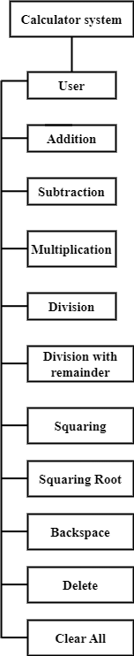

### System Context Diagram

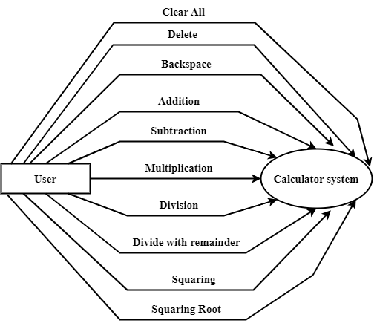

## Software Requirement Specification

### High level Functional Requirement (FR)

|  |  |  |
| --- | --- | --- |
| **FR1.1** | **Title** | **Addition** |
| User | Actor uses this Use Case to demonstrate additional calculation to the system. |
| Description | The user selects the addition function on the main interface, then the system opens an additional calculation interface, awaiting user input for the number 1 and number 2 to be calculated. The users enter number 1 and number 2 to be added into the provided fields on the interface. The system validates the input data for accuracy and validity. Then, it displays the result on the interface and provides options for the user to clear calculation and do it again or exit the additional interface. |
| **FR1.2** | **Title** | **Subtraction** |
| User | Actor uses this Use Case to demonstrate subtraction calculation to the system. |
| Description | The user selects the addition function on the main interface, then the system opens a subtraction calculation interface, awaiting user input for the numbers to be calculated. The users enters number 1 and number 2 to be added into the provided fields on the interface. The system validates the input data for accuracy and validity. Then, it performs a subtraction calculation of 2 numbers and displays the result on the interface. Then, provides options for the user to clear calculation and do it again or exit the subtraction interface. |
| **FR1.3** | **Title** | **Multiplication** |
| User | Actor uses this Use Case to demonstrate multiplication calculation to the system. |
| Description | The user selects the addition function on the main interface, then the system opens a multiplication calculation interface, awaiting user input for the numbers to be calculated. The users enter number 1 and number 2 to be added into the provided fields on the interface. The system validates the input data for accuracy and validity. Then, it performs a multiplication calculation of 2 numbers and displays the result on the interface. Then, provides options for the user to clear calculation and do it again or exit the multiplication interface. |
| **FR1.4** | **Title** | **Division** |
| User | Actor uses this Use Case to demonstrate division calculation to the system. |
| Description | The user selects the addition function on the main interface, then the system opens a division calculation interface, awaiting user input for the numbers to be calculated. The users enter number 1 and number 2 to be added into the provided fields on the interface. The system validates the input data for accuracy and validity. Then, it performs a division calculation of 2 numbers and displays the result on the interface. Then, provides options for the user to clear calculation and do it again or exit the division interface. |
| **FR1.5** | **Title** | **Division with remainder** |
| User | Actor uses this Use Case to demonstrate division with remainder calculation to the system. |
| Description | The user selects the addition function on the main interface, then the system opens a division with remainder calculation interface, awaiting user input for the numbers to be calculated. The users enter number 1 and number 2 to be added into the provided fields on the interface. The system validates the input data for accuracy and validity. Then, it performs division with remainder calculation of 2 numbers and displays the result on the interface. Then, provides options for the user to clear calculation and do it again or exit the division with remainder interface. |
| **FR1.6** | **Title** | **Squaring** |
| User | Actor uses this Use Case to demonstrate square calculation to the system. |
| Description | The user selects the square function on the main interface, then the system opens a square calculation interface, awaiting user input for the number to be calculated. The users enter a number to be added into the provided field on the interface. The system validates the input data for accuracy and validity. Then, it performs square calculation of number and displays the result on the interface. Then, provides options for the user to clear calculation and do it again or exit the square interface. |
| **FR1.7** | **Title** | **Square Root** |
| User | Actor uses this Use Case to demonstrate square root calculation to the system. |
| Description | The user selects the square root function on the main interface, then the system opens a square root calculation interface, awaiting user input for the number to be calculated. The users enter a number to be added into the provided field on the interface. The system validates the input data for accuracy and validity. Then, it performs square root calculation of number and displays the result on the interface. Then, provides options for the user to clear calculation and do it again or exit the square root interface. |
| **FR1.8** | **Title** | **Backspace** |
| User | Actor uses this Use Case to demonstrate backspace function to the system. |
| Description | The user selects any function on the main interface, then the system opens the interface of that function and it has a backspace function, waiting for the user to enter a number to calculate. The user enters the number to add into the field provided on the interface. If the user wants to delete each digit from right to left, use the backspace function, and the user will re-enter. |
| **FR1.9** | **Title** | **Delete** |
| User | Actor uses this Use Case to demonstrate delete function to the system. |
| Description | The user selects any function on the main interface, then the system opens the interface of that function and it has a delete function, waiting for the user to enter a number to calculate. The user enters the number to add into the field provided on the interface. If the user wants to delete each digit from left to right, use the delete function, and the user will re-enter. |
| **FR1.10** | **Title** | **Clear All** |
| User | Actor uses this Use Case to demonstrate clear all function to the system. |
| Description | The user selects any function on the main interface, then the system opens the interface of that function and it has a clear all function, waiting for the user to enter number to calculate. If the user wants to delete and re-enter the number for calculation, click the Clear All function. |

### Stakeholders

|  |  |
| --- | --- |
| **Stakeholder** | **Description** |
| User (Staff of Streamline Calculations Incorporated) | System user |

### Use case

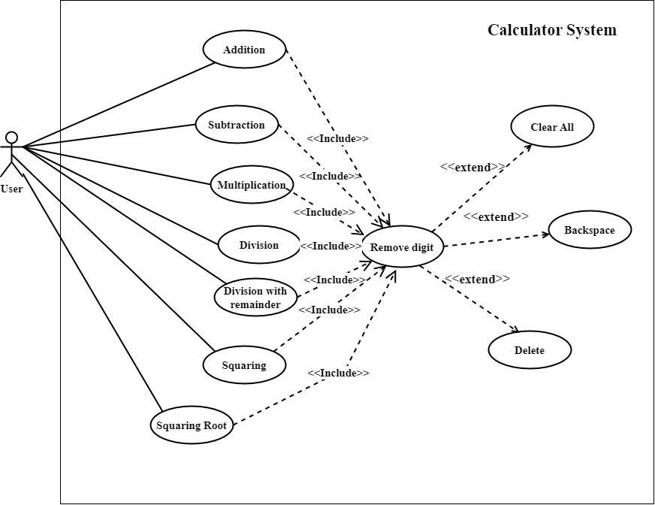

### List of use case

|  |  |  |
| --- | --- | --- |
| **Use case ID** | **Use case name** | **Functional Req.** |
| UC.01 | Addition | FR.1 |
| UC.02 | Subtraction | FR.2 |
| UC.03 | Multiplication | FR.3 |
| UC.04 | Division | FR.4 |
| UC.05 | Division with remainder | FR.5 |
| UC.06 | Squaring | FR.6 |
| UC.07 | Square Root | FR.7 |
| UC.08 | Backspace | FR.8 |
| UC.09 | Delete | FR.9 |
| UC.10 | Clear All | FR.10 |

**2.4.5.Use Case Specification**

##### UC 01: Addition

1. Use Case Diagram



1. Use Case Specification

|  |  |  |  |  |  |
| --- | --- | --- | --- | --- | --- |
| Use case ID | UC.01 | | | | |
| Use case name | **Addition** | | | | |
| Create by | Quang Hieu | | **Last updated by** | | Quang Hieu |
| Date created | January 21, 2024 | | **Date last updated** | | January 24, 2024 |
| Actor | Users of the system, including: Staff of Streamline Calculations Incoporated | | | | |
| Description | This use case shows the process followed by a user demonstrate addition calculation in the Calculation System. | | | | |
| Trigger | Click to “**+**” in navigator at home page | | | | |
| Pre-condition | None | | | | |
| Post-condition | If the use case is successful. The system opens a addition calculation interface. | | | | |
| Main Success Scenario: | **Step** | **Actor Action** | | **System Response** | |
| 1 | Click to “**+**” in navigator at main interface | | Redirect to Addition interface | |
| 2 | Fill out two data fields: number 1 and number 2 | |  | |
| 3 | Click to “**+**” button. | | The system will perform the calculation of addition two numbers, (data type of double or integer), then print the results to the screen. | |
| 4 | Click to “Clear” button if want to continue. | | The system will delete data of number 1, number 2 and results. Allows users to enter data and perform calculations. | |
| Alternative Scenario | **Step** | **Actor Action** | | **System Response** | |
| 1 | Click to “**+**” in navigator at main interface | | Redirect to Addition interface | |
| 2 | Fill out two data fields: number 1 and number 2 | |  | |
| 3 | Click to “**+**” button. | | The system will display an error message. User can enter again number 1 and number 2. | |
| Exception | **Step** | **Actor Action** | | **System Response** | |
| 1 | Input data is invalid | | Show message: "Error! The value you enter must be a real number." | |
| Priority | High | | | | |
| Business rule | N/A | | | | |
| Description: | This function allows users to perform addition of two numbers. By entering two numbers of integer or decimal type. You are not allowed to enter other characters. If you do, you will receive an error message. Also allows users to re-enter if desired. | | | | |

##### UC 02: Subtraction

1. Use Case Diagram



1. Use Case Specification

|  |  |  |  |  |  |
| --- | --- | --- | --- | --- | --- |
| Use case ID | UC.02 | | | | |
| Use case name | **Subtraction** | | | | |
| Create by | Quang Hieu | | **Last updated by** | | Quang Hieu |
| Date created | January 21, 2024 | | **Date last updated** | | January 24, 2024 |
| Actor | Users of the system, including: Staff of Streamline Calculations Incoporated | | | | |
| Description | This use case shows the process followed by a user demonstrate subtraction calculation in the Calculation System. | | | | |
| Trigger | Click to “**-**” in navigator at home page | | | | |
| Pre-condition | None | | | | |
| Post-condition | If the use case is successful. The system opens a subtraction calculation interface. | | | | |
| Main Success Scenario: | **Step** | **Actor Action** | | **System Response** | |
| 1 | Click to “**-**” in navigator at main interface | | Redirect to subtraction interface | |
| 2 | Fill out two data fields: number 1 and number 2 | |  | |
| 3 | Click to “**-**” button. | | The system will perform the calculation of subtraction two numbers, (data type of double or integer), then print the results to the screen. | |
| 4 | Click to “Clear” button if want to continue. | | The system will delete data of number 1, number 2 and results. Allows users to enter data and perform calculations. | |
| Alternative Scenario | **Step** | **Actor Action** | | **System Response** | |
| 1 | Click to “**-**” in navigator at main interface | | Redirect to subtraction interface | |
| 2 | Fill out two data fields: number 1 and number 2 | |  | |
| 3 | Click to “**-**” button. | | The system will display an error message. User can enter again number 1 and number 2. | |
| Exception | **Step** | **Actor Action** | | **System Response** | |
| 1 | Input data is invalid | | Show message: "Error! The value you enter must be a real number." | |
| Priority | High | | | | |
| Business rule | N/A | | | | |
| Description: | This function allows users to perform subtraction of two numbers. By entering two numbers of integer or decimal type. You are not allowed to enter other characters. If you do, you will receive an error message. Also allows users to re-enter if desired. | | | | |

##### UC 03: Multiplication

1. Use Case Diagram



1. Use Case Specification

|  |  |  |  |  |  |
| --- | --- | --- | --- | --- | --- |
| Use case ID | UC.03 | | | | |
| Use case name | **Multiplication** | | | | |
| Create by | Quang Hieu | | **Last updated by** | | Quang Hieu |
| Date created | January 21, 2024 | | **Date last updated** | | January 24, 2024 |
| Actor | Users of the system, including: Staff of Streamline Calculations Incoporated | | | | |
| Description | This use case shows the process followed by a user demonstrate multiplication calculation in the Calculation System. | | | | |
| Trigger | Click to “**\***” in navigator at home page | | | | |
| Pre-condition | None | | | | |
| Post-condition | If the use case is successful. The system opens a multiplication calculation interface. | | | | |
| Main Success Scenario: | **Step** | **Actor Action** | | **System Response** | |
| 1 | Click to “**\***” in navigator at main interface | | Redirect to multiplication interface | |
| 2 | Fill out two data fields: number 1 and number 2 | |  | |
| 3 | Click to “**\***” button. | | The system will perform the calculation of multiplication two numbers, (data type of double or integer), then print the results to the screen. | |
| 4 | Click to “Clear” button if want to continue. | | The system will delete data of number 1, number 2 and results. Allows users to enter data and perform calculations. | |
| Alternative Scenario | **Step** | **Actor Action** | | **System Response** | |
| 1 | Click to “**\***” in navigator at main interface | | Redirect to Addition interface | |
| 2 | Fill out two data fields: number 1 and number 2 | |  | |
| 3 | Click to “**\***” button. | | The system will display an error message. User can enter again number 1 and number 2. | |
| Exception | **Step** | **Actor Action** | | **System Response** | |
| 1 | Input data is invalid | | Show message: "Error! The value you enter must be a real number." | |
| Priority | High | | | | |
| Business rule | N/A | | | | |
| Description: | This function allows users to perform multiplication of two numbers. By entering two numbers of integer or decimal type. You are not allowed to enter other characters. If you do, you will receive an error message. Also allows users to re-enter if desired. | | | | |

##### UC 04: Division

1. Use Case Diagram



1. Use Case Specification

|  |  |  |  |  |  |
| --- | --- | --- | --- | --- | --- |
| Use case ID | UC.04 | | | | |
| Use case name | **Division** | | | | |
| Create by | Huynh Duc Huy | | **Last updated by** | | Huynh Duc Huy |
| Date created | January 21, 2024 | | **Date last updated** | | January 24, 2024 |
| Actor | Users of the system, including: Staff of Streamline Calculations Incoporated | | | | |
| Description | This use case shows the process followed by a user demonstrate division calculation in the Calculation System. | | | | |
| Trigger | Click to “**/**” in navigator at home page | | | | |
| Pre-condition | None | | | | |
| Post-condition | If the use case is successful. The system opens a division calculation interface. | | | | |
| Main Success Scenario: | **Step** | **Actor Action** | | **System Response** | |
| 1 | Click to “**/**” in navigator at main interface | | Redirect to division interface | |
| 2 | Fill out two data fields: number 1 and number 2 | |  | |
| 3 | Click to “**/**” button. | | The system will perform the calculation of division two numbers, (data type of double or integer), then print the results to the screen. | |
| 4 | Click to “Clear” button if want to continue. | | The system will delete data of number 1, number 2 and results. Allows users to enter data and perform calculations. | |
| Alternative Scenario | **Step** | **Actor Action** | | **System Response** | |
| 1 | Click to “**/**” in navigator at main interface | | Redirect to division interface | |
| 2 | Fill out two data fields: number 1 and number 2 | |  | |
| 3 | Click to “**/**” button. | | The system will display an error message. User can enter again number 1 and number 2. | |
| Exception | **Step** | **Actor Action** | | **System Response** | |
| 1 | * Input data is invalid * Divisor has value equal to 0. | | * Show message: "Error! The value you enter must be a real number." * “Error, divisor must be different from 0.” | |
| Priority | High | | | | |
| Business rule | N/A | | | | |
| Description: | This function allows users to perform division of two numbers. By entering two numbers of integer or decimal type. You are not allowed to enter other characters or number 2 has value equal to 0. If you do, you will receive an error message. Also allows users to re-enter if desired. | | | | |

##### UC 05: Division with raminder

1. Use Case Diagram



1. Use Case Specification

|  |  |  |  |  |  |
| --- | --- | --- | --- | --- | --- |
| Use case ID | UC.05 | | | | |
| Use case name | **Division with remainder** | | | | |
| Create by | Huynh Duc Huy | | Create by | | Huynh Duc Huy |
| Date created | January 21, 2024 | | Date created | | January 24, 2024 |
| Actor | Users of the system, including: Staff of Streamline Calculations Incoporated | | | | |
| Description | This use case shows the process followed by a user demonstrate division with remainder calculation in the Calculation System. | | | | |
| Trigger | Click to “**%**” in navigator at home page | | | | |
| Pre-condition | None | | | | |
| Post-condition | If the use case is successful. The system opens a division with remainder calculation interface. | | | | |
| Main Success Scenario: | **Step** | **Actor Action** | | **System Response** | |
| 1 | Click to “**%**” in navigator at main interface | | Redirect to division with remainder interface | |
| 2 | Fill out two data fields: number 1 and number 2 | |  | |
| 3 | Click to “**%**” button. | | The system will perform the calculation of division with remainder two numbers, (data type of double or integer), then print the results to the screen. | |
| 4 | Click to “Clear” button if want to continue. | | The system will delete data of number 1, number 2 and results. Allows users to enter data and perform calculations. | |
| Alternative Scenario | **Step** | **Actor Action** | | **System Response** | |
| 1 | Click to “**%**” in navigator at main interface | | Redirect to division with remainder interface | |
| 2 | Fill out two data fields: number 1 and number 2 | |  | |
| 3 | Click to “**%**” button. | | The system will display an error message. User can enter again number 1 and number 2. | |
| Exception | **Step** | **Actor Action** | | **System Response** | |
| 1 | * Input data is invalid * Divisor has value equal to 0. | | * Show message: "Error! The value you enter must be a real number." * “Error, divisor must be different from 0.” | |
| Priority | High | | | | |
| Business rule | N/A | | | | |
| Description: | This function allows users to perform division with remainder of two numbers. By entering two numbers of integer or decimal type. You are not allowed to enter other characters or number 2 has value equal to 0. If you do, you will receive an error message. Also allows users to re-enter if desired. | | | | |

##### UC 06: Squaring

1. Use Case Diagram



1. Use Case Specification

|  |  |  |  |  |  |
| --- | --- | --- | --- | --- | --- |
| **Use case ID** | UC.06 | | | | |
| **Use case name** | **Squaring** | | | | |
| **Create by** | Quang Hieu | | **Last updated by** | | Quang Hieu |
| **Date created** | March 1, 2024 | | **Date last updated** | | March 1, 2024 |
| **Actor** | Users of the system, including: Staff of Streamline Calculations Incoporated | | | | |
| **Description** | This use case shows the process followed by a user demonstrate square calculation in the Calculation System. | | | | |
| **Trigger** | Click to “X ^ 2” in navigator at home page | | | | |
| **Pre-condition** | None | | | | |
| **Post-condition** | If the use case is successful. The system opens a square calculation interface. | | | | |
| **Main Success Scenario:** | **Step** | **Actor Action** | | **System Response** | |
| 1 | Click to “Square” in navigator at main interface | | Redirect to square interface | |
| 2 | Fill out data field: number | |  | |
| 3 | Click to “X ^ 2” button. | | The system will perform the calculation of square a number, (data type of double or integer), then print the result to the screen. | |
| 4 | Click to “Clear” button if want to continue. | | The system will delete data of number 1 and result. Allows users to enter data and perform calculations. | |
| **Alternative Scenario** | **Step** | **Actor Action** | | **System Response** | |
| 1 | Click to “Square” in navigator at main interface | | Redirect to Square interface | |
| 2 | Fill out data field: number | |  | |
| 3 | Click to “X ^ 2” button. | | The system will display an error message. User can enter number again. | |
| **Exception** | **Step** | **Actor Action** | | **System Response** | |
| 1 | Input data is invalid | | Show message: "Error! The value you enter must be a real number." | |
| **Priority** | High | | | | |
| **Business rule** | N/A | | | | |
| **Description:** | This function allows users to perform square of number. By entering a number of integer or decimal type. You are not allowed to enter other characters. If you do, you will receive an error message. Also allows users to re-enter if desired. | | | | |

##### UC 07: Squaring Root

1. Use Case Diagram



1. Use Case Specification

|  |  |  |  |  |  |
| --- | --- | --- | --- | --- | --- |
| **Use case ID** | UC.07 | | | | |
| **Use case name** | **Squaring Root** | | | | |
| **Create by** | Quang Hieu | | **Last updated by** | | Quang Hieu |
| **Date created** | March 1, 2024 | | **Date last updated** | | March 1, 2024 |
| **Actor** | Users of the system, including: Staff of Streamline Calculations Incoporated | | | | |
| **Description** | This use case shows the process followed by a user demonstrate square root calculation in the Calculation System. | | | | |
| **Trigger** | Click to “√” in navigator at home page | | | | |
| **Pre-condition** | None | | | | |
| **Post-condition** | If the use case is successful. The system opens a square root calculation interface. | | | | |
| **Main Success Scenario:** | **Step** | **Actor Action** | | **System Response** | |
| 1 | Click to “Square root” in navigator at main interface | | Redirect to square root interface | |
| 2 | Fill out data field: number | |  | |
| 3 | Click to “√” button. | | The system will perform the calculation of square root a number, (data type of double or integer), then print the result to the screen. | |
| 4 | Click to “Clear” button if want to continue. | | The system will delete data of number 1 and result. Allows users to enter data and perform calculations. | |
| **Alternative Scenario** | **Step** | **Actor Action** | | **System Response** | |
| 1 | Click to “Square root” in navigator at main interface | | Redirect to Square root interface | |
| 2 | Fill out data field: number | |  | |
| 3 | Click to “√” button. | | The system will display an error message. User can enter number again. | |
| **Exception** | **Step** | **Actor Action** | | **System Response** | |
| 1 | * Input data is invalid. * Data is a negative number. | | * Show message: "Error! The value you enter must be a real number." * Show messgae: “MATH ERROR!”. | |
| **Priority** | High | | | | |
| **Business rule** | N/A | | | | |
| **Description:** | This function allows users to perform square root of number. By entering a number of integer or decimal type. You are not allowed to enter other characters or a negative number. If you do, you will receive an error message. Also allows users to re-enter if desired. | | | | |

##### UC 08: Backspace

1. Use Case Diagram

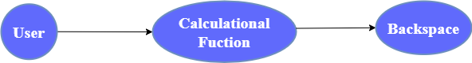

1. Use Case Specification

|  |  |  |  |  |  |
| --- | --- | --- | --- | --- | --- |
| **Use case ID** | UC.08 | | | | |
| **Use case name** | **Backspace** | | | | |
| **Create by** | Quang Hieu | | **Last updated by** | | Quang Hieu |
| **Date created** | March 1, 2024 | | **Date last updated** | | March 1, 2024 |
| **Actor** | Users of the system, including: Staff of Streamline Calculations Incoporated | | | | |
| **Description** | This use case shows the process followed by a user demonstrate backspace function in the Calculation System. | | | | |
| **Trigger** | Click to “🡨” in navigator at home page | | | | |
| **Pre-condition** | None | | | | |
| **Post-condition** | If the use case is successful. The system delete each digit from right to left. | | | | |
| **Main Success Scenario:** | **Step** | **Actor Action** | | **System Response** | |
| 1 | Click to any calculation interface | | Redirect to a calculation interface | |
| 2 | Fill out data field: number | |  | |
| 3 | Click to “🡨” button. | | The system will delete each digit from right to left. | |
| 4 | Re-enter number | | Allows users to re-enter data and perform calculations. | |
| **Priority** | High | | | | |
| **Business rule** | N/A | | | | |
| **Description:** | This function allows users to delete each digit from right to left. By clicking backspace button on the interface. And then users can re-enter number if desired. | | | | |

##### UC 09: Delete

1. Use Case Diagram



1. Use Case Specification

|  |  |  |  |  |  |
| --- | --- | --- | --- | --- | --- |
| **Use case ID** | UC.09 | | | | |
| **Use case name** | **Delete** | | | | |
| **Create by** | Quang Hieu | | **Last updated by** | | Quang Hieu |
| **Date created** | March 1, 2024 | | **Date last updated** | | March 1, 2024 |
| **Actor** | Users of the system, including: Staff of Streamline Calculations Incoporated | | | | |
| **Description** | This use case shows the process followed by a user demonstrate delete function in the Calculation System. | | | | |
| **Trigger** | Click to “🡪” in navigator at home page | | | | |
| **Pre-condition** | None | | | | |
| **Post-condition** | If the use case is successful. The system delete each digit from left to right. | | | | |
| **Main Success Scenario:** | **Step** | **Actor Action** | | **System Response** | |
| 1 | Click to any calculation interface | | Redirect to a calculation interface | |
| 2 | Fill out data field: number | |  | |
| 3 | Click to “🡪” button. | | The system will delete each digit from left to right. | |
| 4 | Re-enter number | | Allows users to re-enter data and perform calculations. | |
| **Priority** | High | | | | |
| **Business rule** | N/A | | | | |
| **Description:** | This function allows users to delete each digit from left to right. By clicking delete button on the interface. And then users can re-enter number if desired. | | | | |

##### UC 10: Clear All

1. Use Case Diagram

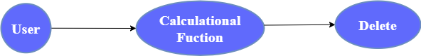

1. Use Case Specification

|  |  |  |  |  |  |
| --- | --- | --- | --- | --- | --- |
| **Use case ID** | UC.10 | | | | |
| **Use case name** | **Squaring** | | | | |
| **Create by** | Quang Hieu | | **Last updated by** | | Quang Hieu |
| **Date created** | March 1, 2024 | | **Date last updated** | | March 1, 2024 |
| **Actor** | Users of the system, including: Staff of Streamline Calculations Incoporated | | | | |
| **Description** | This use case shows the process followed by a user demonstrate clear all function in the Calculation System. | | | | |
| **Trigger** | Click to “Clear” in navigator at home page | | | | |
| **Pre-condition** | None | | | | |
| **Post-condition** | If the use case is successful. The system delete all number. | | | | |
| **Main Success Scenario:** | **Step** | **Actor Action** | | **System Response** | |
| 1 | Click to any calculation interface | | Redirect to a calculation interface. | |
| 2 | Fill out data field: number | |  | |
| 3 | Click to “Clear” button. | | The system will delete all number that you entered. | |
| 4 | Re-enter number | | Allows users to re-enter data and perform calculations. | |
| **Priority** | High | | | | |
| **Business rule** | N/A | | | | |
| **Description:** | This function allows users to delete all number. By clicking Clear button on the interface. And then users can re-enter number if desired. | | | | |

## 2.4.6 . Activity Diagrams

## Addition

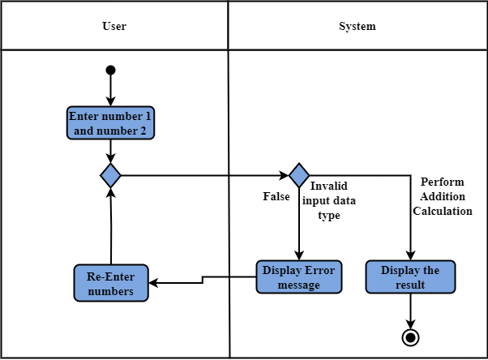

## Subtraction

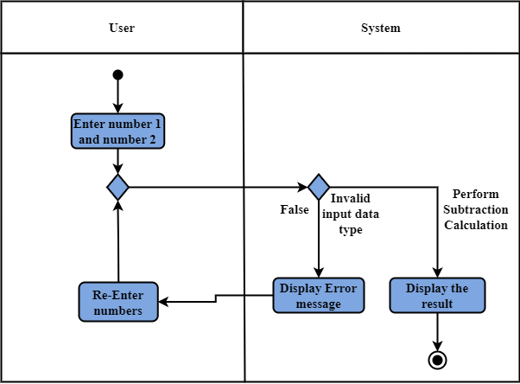

## Multiplication

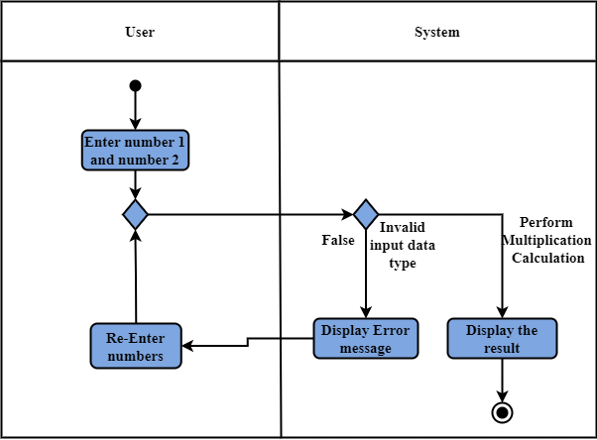

## Division

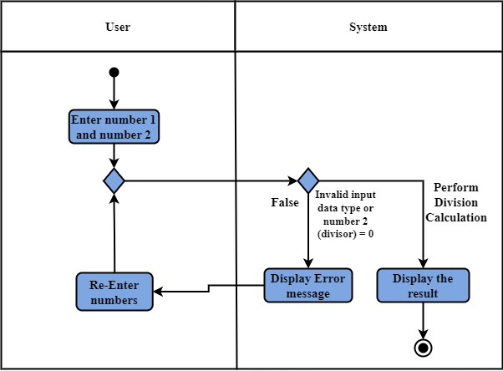

## Division with remainder

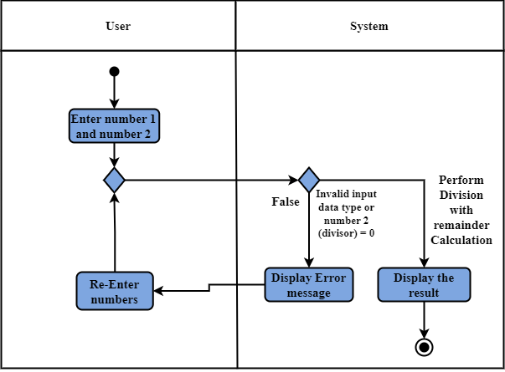

## Square

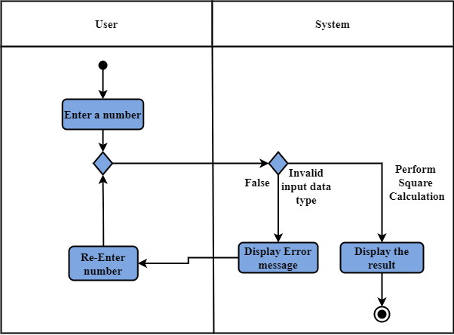

## Square Root

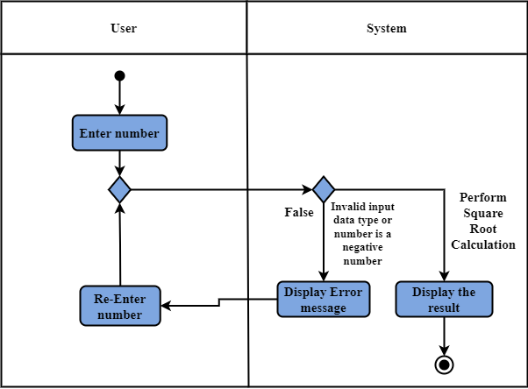

## Backspace

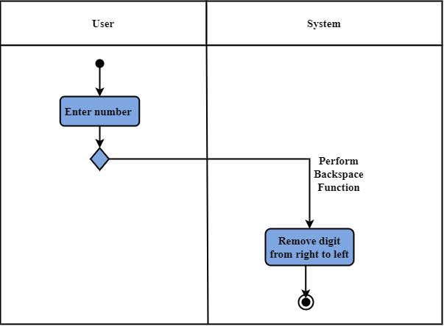

## Delete

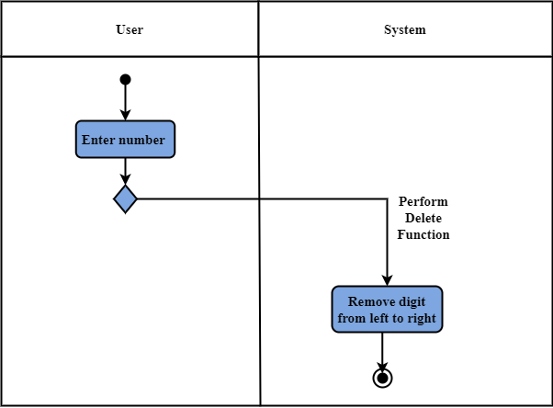

## Clear All

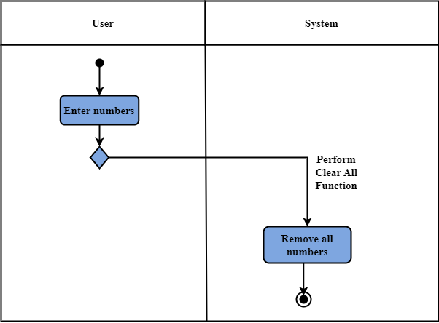

# Appendix A: Glossary

|  |  |
| --- | --- |
| FR | Functional Requirement |
| QA | Quality Attribute |
| UC | Use case |
| BR | Business rule |